**Sign Language To Speech**

**Conversion**

**PHASE I PROJECT**

**REPORT**

***Submitted by***

|  |  |
| --- | --- |
| **MAHENDRAN R**  **SAM PRAKASH A**  **SELVA GANESH J**  **MUNEESWARAN M** | **711522BEE027**  **711522BEE051**  **711522BEE304**  **71521BEE501** |

***in partial fulfillment for the award of the degree***

***of***

**BACHELOR OF ENGINEERING**

**in**

**ELECTRICAL AND ELECTRONICS**

**ENGINEERING**



**KIT-KALAIGNARKARUNANIDHI INSTITUTE OF TECHNOLOGY (AN AUTONOMOUS INSTITUTION)**

**COIMBATORE-641402**

## ANNA UNIVERSITY:CHENNAI 600 025

**NOVEMBER 2024**

**KIT-KALAIGNARKARUNANIDHI INSTITUTE OF TECHNOLOGY (AN AUTONOMOUS INSTITUTION) COIMBATORE-641402**

## BONAFIDE CERTIFICATE

Certified that this project report **“SIGN LANGUAGE TO SPEECH CONVERSION”** is the Bonafide work of **MAHENDRAN R (71522BEEO27), SAM PRAKASH A (71522BEE051), SELVA GANESH J (71522BEE304), MUNEESWAREN M (711521BEE501)** who carried out the project work under my supervision. Certified further, that to the best of my knowledge the work reported here in does not form part of any other project report or dissertation on the basis of which a degree or awarded was conferred on a earlier occasion on this or any other candidate.

|  |  |
| --- | --- |
| **SIGNATURE**  **Dr. R. MYTHILI**  **HEAD OF THE DEPARTMENT**  Department of Electrical and Electronics Engineering  KIT-Kalaignarkarunanidhi  Institute of Technology,  Coimbatore- 641402 | **SIGNATURE**  **Mr. K. PRADHEEP M.E(PhD)**  **SUPERVISOR**  Assistant Professor  Department of Electrical and Electronics Engineering  KIT-Kalaignarkarunanidhi  Institute of Technology,  Coimbatore- 641402 |

Submitted for the university Project vivavoce Examination held on…..

|  |  |
| --- | --- |
| **Internal Examiner** | **External Examiner** |

**KIT-KALAIGNARKARUNANIDHI INSTITUTE OF TECHNOLOGY (AN AUTONOMOUS INSTITUTION) COIMBATORE-641402**

**DECLARATION**

We jointly declare that the project report on **“SIGN LANGUAGE TO SPEECH CONERSON”** is the result of original work done by us and best of our Knowledge, similar work has not been submitted to **“ANNA UNIVERSITY CHENNAI”** for the requirement of Degree of Bachelor of Engineering in Electrical and Electronics Engineering. This project report is submitted on the partial fulfilment of the requirement of the award of Degree of Bachelor of Engineering in Electrical and Electronics Engineering.

**Signature**

MAHENDRAN R

SAM PRAKASH A

SELVA GANESH J

MUNEESWAREN M

|  |
| --- |
| Place: Coimbatore  Date: |

# **ACKNOWLEDGEMENT**

Owing deeply to the supreme, we extend our sincere thanks to God almighty who has made all things possible.

We extend our heartful gratitude towards our revered Founder Chairman **Thiru Pongalur N. Palanisamy** and Vice Chairperson **Mrs. Indu Murugesan** for providing us with necessary infrastructure to undertake this project work.

We wish to express our sincere gratitude to our beloved CEO **Dr. N. Mohan Das Gandhi,** Principal **Dr. M. Ramesh** and Dean (Academics & Research) **Dr. K. Ramasamy** for the facilities provided to complete this project work.

Our gratitude passes on to **Dr. R. Mythili**, Head of the Department, Electrical and Electronics Engineering, for her valuable support and encouragement during this project.

We are grateful to **Mr. K. Pradheep,** Assistant Professor, Department of Electrical and Electronics Engineering, the project supervisor and project coordinator for his timely suggestions, constant encouragement and support that led to the accomplishment of the project.

The acknowledgement would be incomplete without a word of thanks to our parents, faculty members and friends for their continuous support and sincere help throughout our project.

MAHENDRAN R

SAM PRAKASH A

SELVA GANESH J

MUNEESWAREN M

# **ABSTRACT**

This project presents a sign language to speech conversion system that can detect and identify the movements of the fingers with flex sensors technology in determining hand gesture. The device records the minute finger movements captured by the wearable device, which are then processed using the micrcocontroller to produce audio and visual outputs. The solution helps overcome the barriers of communication that the speech-impaired population of india face-offs, thus enabling real time inclusive interactions and independence. It is inexpensive, portable, and flexible to allow for local differences in sign language. The system thus offers a cost effective, autonomous alternative for personal communication. Its possible application lies not only in personal communication but also in educational, medical, and customer service scenarios where interaction barriers exist. The system uses modern technology to improve accessibility and promote digital connection. Its design is flexible, making it easy to upgrade or add more languages in the future. This innovation aims to improve the lives of the speech-impaired community by helping them become more independent.

**Keywords:-** Sign language, Speech Conversion System, Flex Sensors, Gesture Recognition, Speech-Impaired Communication, Accessibility, Digital Connection, Wearable Technology, Microcontroller, Audio and Visual Outputs, Real-Time Interaction, Cost-Effective Communication, Language Adaptation, Assistive Technology, Speech-Impaired Community, Digital Connection.

**TABLE OF CONTENTS**

|  |  |  |
| --- | --- | --- |
| **CHAPTER NO** | **TITLE** | **PAGE NO** |
|  | ACKNOWLEDGEMENT | iv |
|  | ABSTRACT | v |
| 1 | INTRODUCTION | vii |
|  | 1.1 Objective of Project  1.2 Project Background  1.3 Problem Statement  1.4 Application | viii  viii  ix  ix |
| 2 | LITERATURE SURVVEY | x |
| 3 | EXISTING SYSTEM | xiii |
|  | 3.1 Existing System  3.2 Disadvantage of Existing System | xiii  xiii |
| 4 | PROPOSED SYSTEM | xiv |
| 5 | COMPONENT USED | xv |
|  | 5.1 Arduino UNO  5.2 Flex Sensor  5.3 DF Mini Player  5.4 LCD Display | xv  xv  xvi  xvi |
| 6 | BLOCK DIAGRAM | xvii |
| 7 | RESULTS | xviii |
|  | 7.1 Simultion  7.2 Project Result | xviii  xviii |
| 8 | CONCLUSION | xix |
| 9 | REFERENCE | xx |

# **CHAPTER 1**

# **INTRODUCTION**

This project focuses on developing a system that translates sign language gestures into audible speech, aiming to assist speech-impaired individuals in communication. It utilizes flex sensors, which detect the bending of fingers during hand gestures, allowing the system to capture and process these movements. The system then generates corresponding audio output, enabling real-time translation of sign language into speech, facilitating easier communication between the speech-impaired and those who do not understand sign language.

In addition to audible speech, the project integrates a 16x2 LCD display to provide a visual output. This feature ensures that individuals who are unable to hear the audio can still access the translated message through text on the screen. The combination of flex sensors, audio output, and visual display creates a comprehensive communication tool for the speech-impaired, enhancing accessibility and interaction in various environments.

The system is designed to be user-friendly and portable, making it suitable for everyday use in a variety of settings. By using flexible sensors that are easy to wear and integrate into gloves or other wearable devices, the technology offers a comfortable and non-intrusive solution for individuals who rely on sign language. Additionally, the system can be adapted to recognize a wide range of gestures, expanding its applicability to different sign language systems. This innovation not only bridges communication gaps but also empowers individuals with speech impairments to express themselves more freely and interact with others in an inclusive manner. With continuous development, this technology has the potential to revolutionize communication for people with speech and hearing impairments worldwide

## OBJECTIVE OF THE PROJECT

* Create a system that translates sign language gestures into audible speech and visual text to facilitate communication for speech-impaired individuals.
* Utilize flex sensors to detect finger movements during hand gestures, processing them to generate corresponding audio and text output.
* Incorporate a 16x2 LCD display for text output and audio for real-time translation, ensuring accessibility for both hearing and non-hearing individuals.
* Design the system to be portable, wearable, and easy to use in daily life, providing a comfortable solution for sign language users.
* Empower individuals with speech impairments to communicate more freely, improving interaction and inclusivity in various settings and across different sign language systems.

### **PROJECT BACKGROUND**

Sign language is essential for communication among speech-impaired individuals, but it often creates barriers when interacting with those who don’t understand it. This project aims to develop a system that translates sign language gestures into audible speech and visual text, facilitating communication between speech-impaired individuals and others. Flex sensors detect finger movements during hand gestures and convert them into corresponding audio and text outputs. A 16x2 LCD display provides visual output, ensuring accessibility for both hearing and non-hearing individuals.

The system is designed to be portable, user-friendly, and wearable, integrating easily into gloves or other devices. It can recognize a wide range of gestures, supporting various sign language systems. This technology bridges communication gaps and empowers speech-impaired individuals to express themselves more freely. Continuous development of the system has the potential to improve communication for individuals with speech and hearing impairments globally.

#### **1.3 PROBLEM STATEMENT**

In India, many individuals face communication barriers due to speech impairments. Sign language, though effective within certain communities, is not universally understood. This project provides an assistive solution that enables real-time communication, helping not only the speech-impaired but also individuals with limited mobility, such as those with paralysis or other physical disabilities. The system offers a bridge between these individuals and society, fostering inclusivity. It can be easily adapted to different regional sign language systems, making it applicable across diverse linguistic communities. Ultimately, this project aims to create a more accessible and inclusive environment for all, regardless of their communication limitations. Despite the growing need for accessible communication tools, existing solutions are often limited in scope, language support, and adaptability. This creates a gap in effectively serving individuals with diverse needs, especially in multilingual and multicultural settings like India. The proposed system aims to overcome these challenges by offering a portable, user-friendly, and adaptable solution that can recognize a wide range of sign language gestures, providing real-time translations to both speech and text.

##### **1.4 APPLICATIONS**

* Enhanced Communication for Speech-Impaired Individuals
* Support for People with Physical Disabilities
* Sign Language Education and Learning
* Healthcare Communication Assistance
* Customer Service and Public Interaction
* Social Inclusion for Non-Speaking Individuals
* Assistive Technology for Elderly People
* Cross-Cultural Communication in Diverse Communities

**CHAPTER 2**

**LITERATURE SURVEY**

In this research, it examines the development and application of a system that translates sign language gestures into both audible speech and visual text, offering a practical solution for the communication needs of speech-impaired individuals. This project is driven by the need to bridge the gap between those who use sign language and those who do not understand it, which often limits interaction in social, educational, and professional environments. The primary objective of the system is to convert sign language gestures into real-time audio and text, enabling speech-impaired individuals to communicate more effectively with the broader population. Sign language, while essential to many individuals, is not universally understood, and this creates a significant communication barrier. By using a combination of flex sensors and a 16x2 LCD display, the system addresses both the hearing and visual needs of individuals, making it accessible in a variety of contexts.

The system’s use of flex sensors is a key component of its design. Flex sensors detect the bending of fingers, which are integral to hand gestures used in sign language. By analyzing these movements, the system can identify specific gestures and translate them into corresponding words or phrases. This requires the system to have highly accurate gesture recognition algorithms that can handle the various nuances of sign language. Flex sensors are advantageous because they are flexible, lightweight, and capable of providing real-time data that can be processed quickly. They also integrate well into wearable devices such as gloves, which make it easy for individuals to use the system in their daily lives without disrupting their routine. The design of such wearable devices is another area of focus in this research, as comfort, ease of use, and portability are all essential considerations for ensuring that the system can be worn for extended periods without causing discomfort.

The integration of a 16x2 LCD display provides a visual output to accompany the audio translation. This dual-output system ensures that individuals who are hearing-impaired or in noisy environments can still benefit from the system's functionality. This feature also enhances the versatility of the system, as it can be used in a variety of scenarios where either text or audio is preferred. The text output is crucial, as it ensures that the system can be used in settings where speaking aloud may not be ideal, such as in quiet public spaces, libraries, or during medical appointments where clear communication is vital. Furthermore, the ability to display text enables a wider audience to understand the message being conveyed, promoting inclusivity and better access to information.

This research also highlights the adaptability of the system to different sign language systems, particularly in multilingual and multicultural regions like India. India has a variety of regional sign languages that differ from state to state, which adds a layer of complexity to sign language recognition. This is why the proposed system is designed to recognize a wide range of gestures across different regional dialects, ensuring that the technology is applicable to diverse linguistic communities. By addressing this need for adaptability, the system can cater to the communication needs of individuals from various cultural backgrounds, improving the overall inclusivity of the system. This is a critical aspect of the research, as many existing systems focus on a limited number of sign languages, often ignoring regional variations or dialects, which creates barriers to communication in multilingual societies.

The system's portability is another significant aspect of this research. Wearable devices that can capture sign language gestures allow individuals to carry the system with them in their everyday lives. This feature is especially beneficial for individuals with speech impairments, as it empowers them to engage in conversations freely without needing to rely on others who understand sign language. The research also explores the benefits of having a portable, easy-to-use solution that can be worn throughout the day, whether in public spaces, at work, or in healthcare settings. This would allow individuals with speech impairments to interact more effectively with the world around them, ultimately improving their social and professional lives.

Furthermore, this research aims to expand the applications of the sign language to speech and text conversion system beyond just individual use. In educational settings, such systems could be used to support the learning of sign language and promote inclusivity for students with hearing or speech impairments. By making the system accessible to teachers and students alike, the technology could play a role in fostering more inclusive classrooms and supporting the educational needs of speech-impaired individuals. Similarly, the healthcare sector stands to benefit from the system’s ability to translate sign language into real-time text and speech. In medical consultations, this technology can assist doctors and healthcare providers in communicating more effectively with patients who use sign language, ultimately improving patient care and reducing misunderstandings. In customer service and public interactions, the technology could enable individuals to interact with service providers more efficiently, overcoming language barriers that typically exist when a speech-impaired person attempts to communicate with someone who doesn’t know sign language.

The research also acknowledges the current challenges faced by similar systems in terms of accuracy, language limitations, and device design. Existing solutions often suffer from a lack of flexibility, supporting only a few select sign languages or requiring bulky hardware.

Existing systems can be hard to use in public and may not be suitable for long-term use. To solve this, the research focuses on creating a lightweight, portable system that recognizes various sign language gestures. It aims to improve gesture recognition by developing better algorithms. This will make the system more efficient and adaptable. The goal is to make it easier to use and suitable for different sign language systems.

**CHAPTER 3**

**EXISTING SYSTEM**

**3.1 EXISTING SYSTEM**

Sign language recognition systems utilize machine learning (ML) algorithms and sensors, such as cameras or accelerometers, to interpret sign language gestures. These systems capture data from the user's gestures and process it to recognize specific signs. Once identified, the system can translate the signs into text or speech, providing a valuable communication tool for the deaf and hard-of-hearing community.

A notable example of this technology is SignAloud, a wearable device designed to translate American Sign Language (ASL) into spoken words. The device uses motion sensors to detect hand movements and other gestures associated with ASL signs. It then processes the sensor data using machine learning models to accurately interpret the signs.

These systems enhance accessibility and communication for individuals who rely on sign language, bridging the gap between sign language users and those who may not be familiar with it. As machine learning and sensor technology continue to advance, such systems will likely become more accurate and widely adopted.

**3.2 DISADVANTAGES OF EXISTING SYSTEM**

* Users must perform signs clearly and consistently for the system to recognize them, which may not align with natural communication styles.
* Different regions and communities use distinct sign languages, and systems may struggle to adapt to all variations effectively.
* Some signs may have multiple meanings depending on the context, making it difficult for machines to determine the correct interpretation.
* Facial expressions and head movements are critical components of sign language and are often difficult to detect and analyze in real time.

**CHAPTER 4**

**PROPOSED SYSTEM**

The proposed system is a wearable device designed to bridge the communication gap for speech-impaired individuals by translating sign language into spoken words. It utilizes flex sensors to detect hand movements, which are then processed by an Arduino UNO to interpret the gestures. The system ensures seamless communication by playing the corresponding voice output through a DF Mini Player connected to a speaker.

One of the key features of this device is its ability to convert gestures into speech in real-time. This capability allows users to communicate more effectively in various social and professional settings. The compact and wearable design ensures convenience and portability, making it suitable for daily use without causing discomfort to the user.

The system is crafted to be highly user-friendly and efficient, requiring minimal technical knowledge for operation. Its intuitive design and quick response make it a practical tool for enhancing communication. By offering a reliable and accessible solution, this device empowers speech-impaired individuals to express themselves effortlessly and engage more fully with the world around them.

**CHAPTER 5**

**COMPONENTS USED**

**COMPONENT USED**

* Arduino UNO
* Flex Sensor
* DF Mini Player
* LCD Display
* 1OK Resistor

**5.1 ARDUINO UNO**

The Arduino Uno is a microcontroller board based on the ATmega328p, designed for prototyping and learning electronics. It features 14 digital I/O pins, 6 analog input, 32 KB flash memory, and operates at 5V with a 16 MHZ clock speed. It is user-friendly and ideal for beginners.

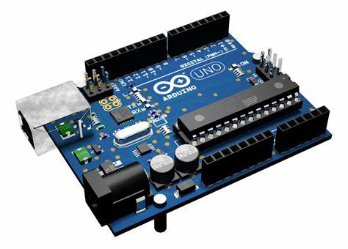

Fig.5.1.Arduino Uno

**5.2 FLEX SENSOR**

A flex sensor is a resistive device that changes resistance based on bending or flexing, with a flat resistance of 25kΩ and operates at 0-5V. Its resistance varies proportionally to the angle of bending, allowing the measurement of flex. It's used in applications like robotics, home control, and speech conversion. The sensor has two leads and acts like a variable resistor, providing an output voltage that changes with its resistance.

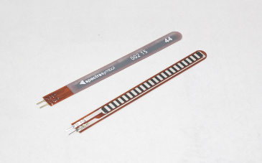

Fig.5.2.Flex Sensor

**5.3 DF MINI PLAYER**

The DF Mini Player plays audio files from a micro SD card and supports formats like MP3, WAV, and WMA. It includes a micro SD slot, built-in amplifier, and 3.5mm audio jack, connecting via UART for Arduino compatibility. Files on the SD card should match names or numbers used in the code. It operates at 3.5V to 5V, with VCC to Arduino 5V, GND to GND, Rx to D10, and Tx to D9.

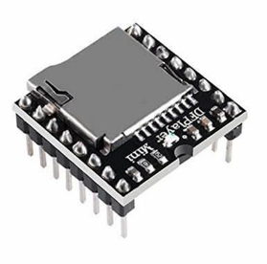

Fig.5.3.DF Mini Player

**5.4 LCD DISPLAY**

The LCD Display 16×2 Module is a popular choice for displaying text and numbers in various electronic devices. It consists of 16 columns and 2 rows of characters, allowing for clear and easy-to-read information presentation. This module utilizes liquid crystal technology to produce sharp, high-contrast images on its screen.

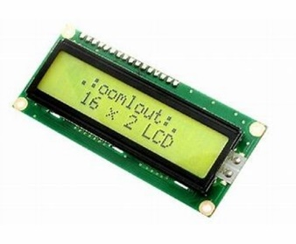

Fig5.4.LCD Display

**CHAPTER 6**

**BLOCK DIAGRAM**

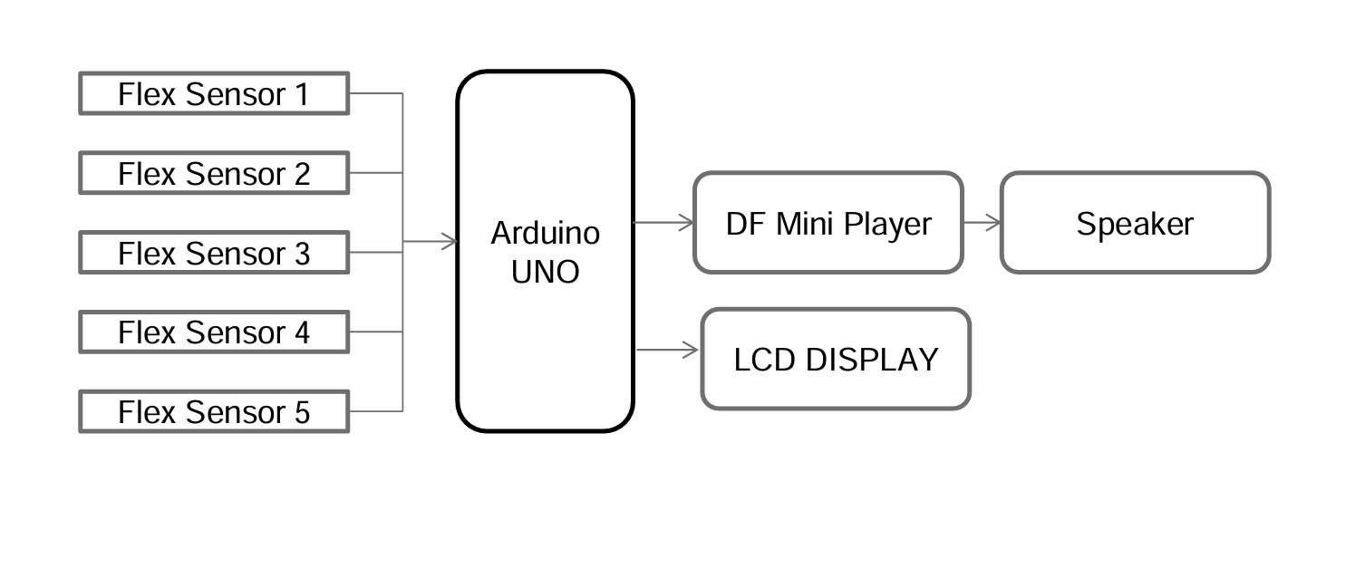

The block diagram represents a wearable device designed to translate sign language into spoken words in real-time. The system includes five flex sensors, each attached to the fingers of a glove or similar wearable. These sensors detect hand movements and finger bending, converting the mechanical changes into electrical signals. These signals are sent to an Arduino UNO, which processes the data and identifies the specific hand gesture being performed. The Arduino then communicates with the DF Mini Player, which contains pre-recorded voice files corresponding to various gestures.

Once the gesture is identified, the DF Mini Player plays the appropriate voice output through a speaker, converting the sign language gesture into spoken words. Additionally, the Arduino sends the recognized gesture to an LCD display, providing a visual representation of the gesture for better clarity. This combination of audio and visual outputs makes the system user-friendly and efficient, allowing speech-impaired individuals to communicate more easily by converting their sign language into real-time speech and text.

**CHAPTER 7**

**RESULTS**

**7.1 SIMULATION**

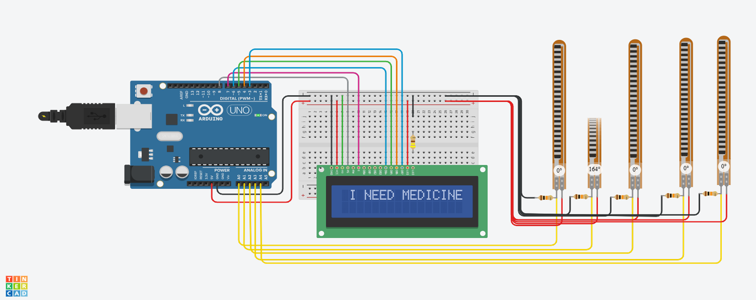

**7.2 PROJECT RESULT**

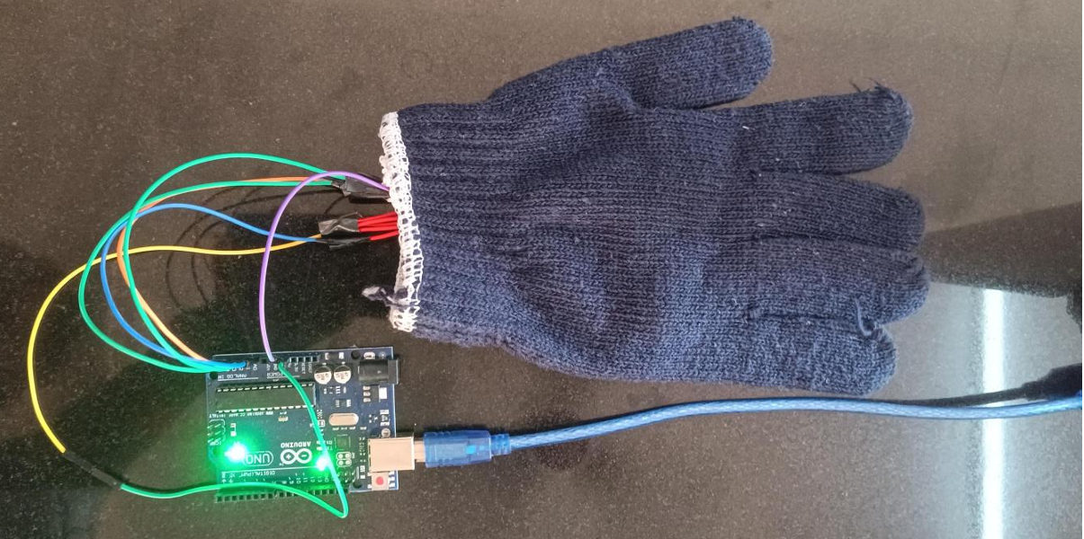

**CHAPTER 8**

**CONCLUSION**

**8 CONCLUSION**

The Sign Language to Speech Conversion project helps speech-impaired individuals communicate by translating hand gestures into audible speech. Using flex sensors, an Arduino Nano, DF Mini Player, speaker, and LCD, it bridges the gap between sign language users and non-users. The LCD display provides a visual message for those unable to hear the audio, promoting inclusivity. This system offers a practical solution, empowering speech-impaired individuals to engage in conversations more easily. Such innovations can improve the quality of life and foster a more inclusive society.

**CHAPTER 9**

**REFERENCES**

1. Rajabov, S. B. (2016). Use of modern information and pedagogical technologies in the activities of coaches and instructors. *Actual Problems of Physical Culture and Sports*, 424-426.
2. Kabilov, A., Rajabov, S. B., Urmanov, B. N. (2021). Problem of optimum control related to environmental issues. *The 5th International Conference on Future Networks & Distributed Systems*, 733-737.
3. Ochilov, S., Rajabov, S. B., Omonov, A. A. (2021). Optimization of time for nonlinear system passing with a parameter through a region. *Modern Problems of Differential Equations and Related Sections*, 1(1), 340-342.
4. Xashimxodjayev, S. I., Sadinov, A. Z., Rajabov, S. B. (2021). Methods of automation and management of waste recycling in the digital economy. *Academic Research in Educational Sciences*, 2(CSPI conference 3), 149-154.
5. Urinovich, K. A., Qobiljonovich, R. O., Baxtiyorvich, R. S., Abdulakhatov, M. M. (2021). Modern content and concept of digital economy. *ACADEMICIA An International Multidisciplinary Research Journal*, 11(11), 829-832.
6. Kobilov, A.U., Rikhsimboev, O.K., Rajabov, S. B. (2021). A global approach to assessing competitiveness in the digital economy. *Economics and Business Theory and Practice*, 11-2, 115-119.
7. Kobilov, A. U., Tulaev, M. S., Rajabov, S. B., Mamatkodirova, N. U. (2021). Legal framework for the formation of the digital economy in the Republic of Uzbekistan. *Economics and Society*, 12(91), 96-104.